**1BABU BANARASI DAS UNIVERSITY**

**LUCKNOW**



**Master Of Computer Application**

**Semester-1**

**School Of Computer Application**

**Web Technology and Application**

**Development Lab**

**Session 2022-23**

### Submitted to:

### Mr. Chandra Kishor Pandey Sir

### Submitted by:

### Syed Waqarul Hasan Naqvi

### Roll No. : 51

### MCA 11

**BABU BANARASI DAS UNIVERSITY**

**LUCKNOW**



**Master Of Computer Application**

**Semester-1**

**School Of Computer Application**

**Web Technology and Application**

**Development Lab**

**Session 2022-23**

### Submitted to:

### Mr. Chandra Kishor Pandey Sir

### Submitted by:

### Rishika Rai

### Roll No. : 01

### MCA 11

**INDEX**

|  |  |  |  |
| --- | --- | --- | --- |
| S.no. | TOPIC | DATE | TEACHER’S SIGN |
| 1. | Html section | 13/04/23 |  |
| 2. | Implementation of List Tags in HTML: | 13/04/23 |  |
| 3. | Unordered ,Ordered & Description List : | 13/04/23 |  |
| 4. | Implementation of Table Tags in HTML: | 13/04/23 |  |
| 5. | Frameset in HTML: | 13/04/23 |  |
| 6. | Implementation of External CSS in Web Pages: | 13/04/23 |  |

**ASSIGNMENT I**

**HTML SECTION**

**<!DOCTYPE html>**

**<html lang="en">**

**<head>**

**<meta charset="UTF-8">**

**<meta http-equiv="X-UA-Compatible" content="IE=edge">**

**<meta name="viewport" content="width=device-width, initial-scale=1.0">**

**<title>Working with html 5</title>**

**</head>**

**<body>**

**<h1><u>Babu banarasi das university</u></h1>**

**<h2><u>Babu banarasi das university</u></h2>**

**<h3><u>Babu banarasi das university</u></h3>**

**<h4><u>Babu banarasi das university</u></h4>**

**<h5><u>Babu banarasi das university</u></h5>**

**<h6><u>Babu banarasi das university</u></h6>**

**<p><strong>BBD</strong> is the <em>best</em> university in lucknow .It offers several courses including ug/pg doctorial program. Placement of this university is about 100%</p>**

**</body>**

**</html>**

# OUTPUT:

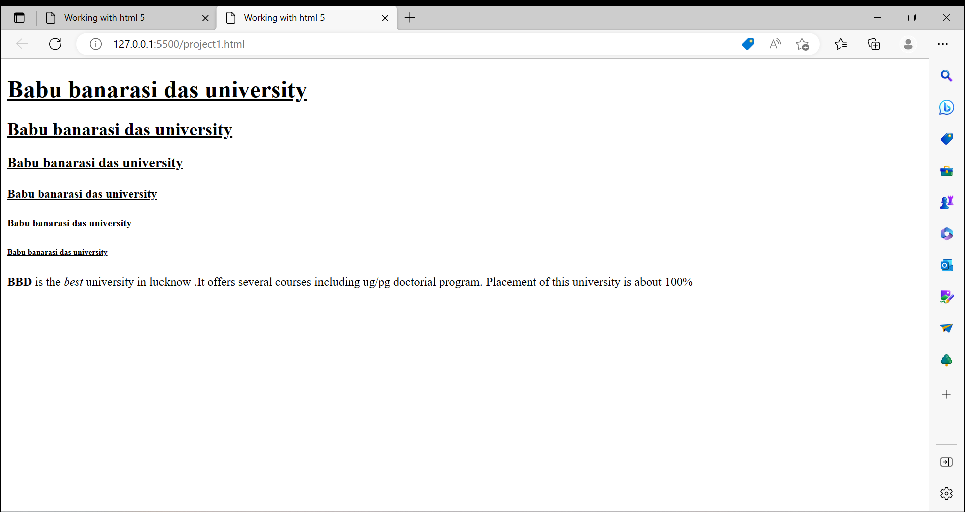

## Implementation of List Tags in HTML:

**<!DOCTYPE html>**

**<html lang="en">**

**<head>**

**<meta charset="UTF-8">**

**<meta http-equiv="X-UA-Compatible" content="IE=edge">**

**<meta name="viewport" content="width=device-width, initial-scale=1.0">**

**<title>Document</title>**

**</head>**

**<body bgcolor="green" text="yellow">**

**<h1><u>MCA II SEM SUBJECTS</u></h1>**

**<ol type="I">**

**<li>MCA4201 :DCA - KJ</li>**

**<li>MCA4202 :DCN - VS</li>**

**<li>MCA4203 :PIP - NS</li>**

**<li>MCA4204 :WAD - CKP</li>**

**<li>MCA4205 :SPM - BDS</li>**

**</ol>**

**<UL type="square"><LI><u>ELECTIVE</u></LI>**

**<OL><LI>MCA4212 :DSML - RAS</LI>**

**<LI>MCA4213 :CC -ANS</LI>**

**</OL>**

**</UL>**

**<DL><DT>MCA</DT>**

**<DD>It is a post graduate computer course.</DD>**

**<dt>BCA</dt>**

**<DD>It is under graduate computer course.</DD>**

**</DL>**

**</body>**

**</html>**

# OUTPUT:

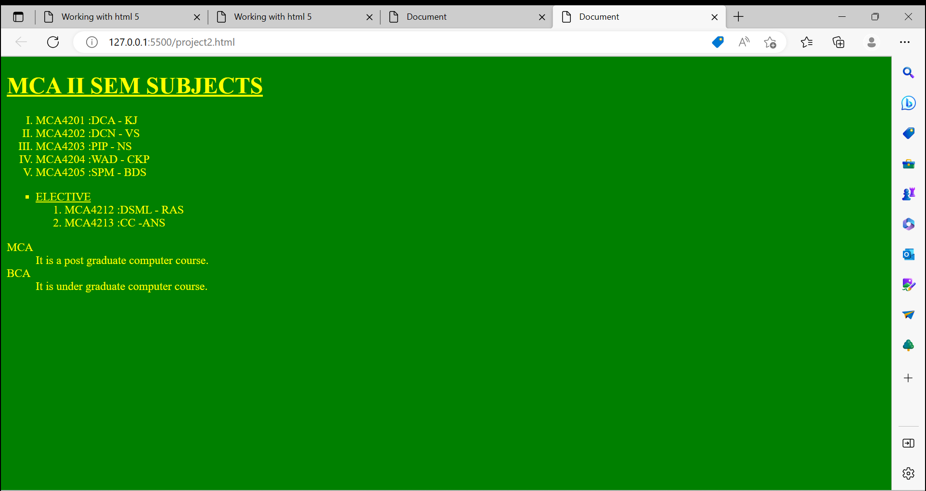

## Unordered ,Ordered & Description List :

**<!DOCTYPE html>**

**<html lang="en">**

**<head>**

**<meta charset="UTF-8">**

**<meta http-equiv="X-UA-Compatible" content="IE=edge">**

**<meta name="viewport" content="width=device-width, initial-scale=1.0">**

**<title>Document</title>**

**</head>**

**<style>**

**h1{**

**background-color: rgb(235, 170, 96);**

**border :2px solid brown;**

**border-radius: 12px;**

**}**

**body{**

**background-color: aqua;**

**}**

**.container{**

**box-sizing: border-box;**

**text-align: center;**

**width: 750px;**

**padding: 12px;**

**margin:23px auto;**

**background-color: rgb(255, 229, 229);**

**border: 4px solid;**

**border-radius: 12px;**

**}**

**.cat{**

**margin:12px auto;**

**width: 450px;**

**background-color: aquamarine;**

**}**

**</style>**

**<body>**

**<div class="container">**

**<h1><u> LIST OF STUDENTS </u></h1>**

**<ul>**

**<li>Pen</li>**

**<li>Pencil</li>**

**<li>Eraser</li>**

**<li>Sharpener</li>**

**<li>Scale</li>**

**</ul>**

**</div>**

**<div class="container">**

**<h1><u>COURSES OFFERED BY BBDU</u> </h1>**

**<OL>**

**<LI>BCA</LI>**

**<LI>BCA DS</LI>**

**<LI>BCA CS & F</LI>**

**<LI>MCA</LI>**

**<LI>MCA DS & AI</LI>**

**</OL>**

**</div>**

**<div class="container">**

**<h1><u>Open Elective choices</u></h1>**

**<div class="container cat">**

**<dl>**

**<dt><u>Cloud Computing :</u></dt>**

**<dd>This subject is a emerging technology in networking & data sharing over a larger span or domain</dd>**

**</dl>**

**</div>**

**<div class="container cat">**

**<dl>**

**<dt><u>DS & ML :</u></dt>**

**<dd>It is latest technology which teals in automation & data storage & management.</dd>**

**</dl>**

**</div>**

**</div>**

**</table>**

**</body>**

**</html>**

# OUTPUT:

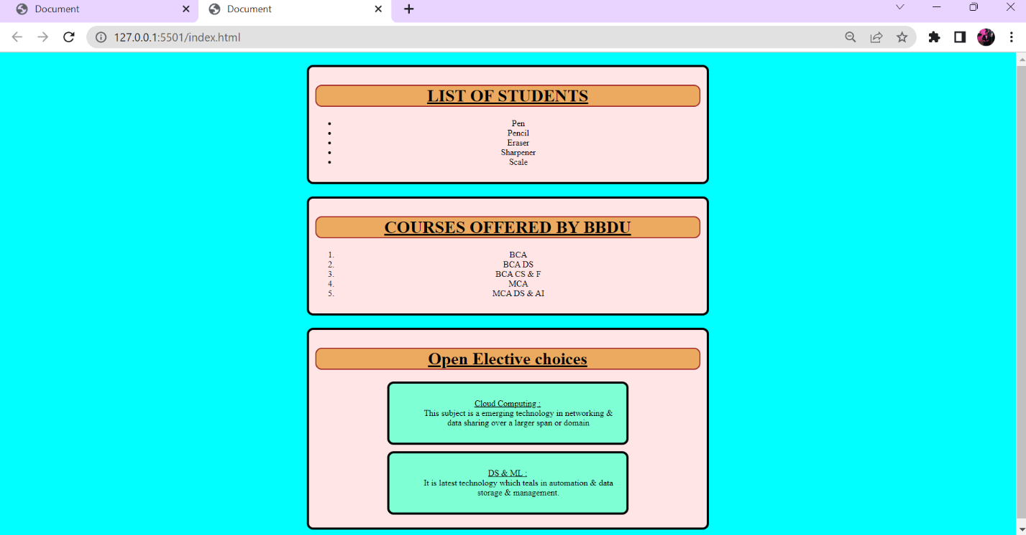

## Implementation of Table Tags in HTML:

**<!DOCTYPE html>**

**<html lang="en">**

**<head>**

**<meta charset="UTF-8">**

**<meta http-equiv="X-UA-Compatible" content="IE=edge">**

**<meta name="viewport" content="width=device-width, initial-scale=1.0">**

**<title>Document</title>**

**</head>**

**<style>**

**h1{**

**background-color: rgb(235, 170, 96);**

**border :2px solid brown;**

**border-radius: 12px;**

**}**

**body{**

**background-color: aqua;**

**}**

**.container{**

**text-align: center;**

**width: 750px;**

**padding: 12px;**

**margin:5% 0% 0% 30%;**

**background-color: rgb(255, 229, 229);**

**border: 4px solid;**

**border-radius: 12px;**

**}**

**table{**

**width: 750px;**

**height: 500px;**

**}**

**.cat{**

**background-color: aquamarine;**

**}**

**thead{**

**background-color: rgb(205, 187, 98);**

**}**

**tbody{**

**background-color: rgb(234, 237, 150);**

**}**

**.tab{**

**background-color: rgb(223, 186, 141);**

**}**

**</style>**

**<body>**

**<div class="container">**

**<h1><u>School of Computer Application</u></h1>**

**<caption></caption>**

**<table border="10">**

**<thead>**

**<tr>**

**<th colspan="5">**

**<strong>  VG & PG COURSES</strong>**

**</th>**

**</tr>**

**<tr><th>S.NO</th>**

**<th>Course Name</td>**

**<th >Specialization</th>**

**<th >Duration</th>**

**<th >Fees</th>**

**</tr>**

**</thead>**

**<tbody>**

**<tr >**

**<td rowspan="4" align="">1</td>**

**<td rowspan="4" align="center">BCA</td>**

**</tr>**

**<tr class="tab">**

**<td>plain </td>**

**<td>3 years</td>**

**<td>70000</td>**

**</tr>**

**<tr  class="tab">**

**<td>CS & F</td>**

**<td>3 years</td>**

**<td>80000</td>**

**</tr>**

**<tr class="tab">**

**<td>ds</td>**

**<td>3 years</td>**

**<td>80000</td>**

**</tr>**

**<tr>**

**<td rowspan="3" align="center">2</td>**

**<td rowspan="3" align="center">MCA</td>**

**</tr>**

**<tr class="tab">**

**<td>plain </td>**

**<td>2 years</td>**

**<td>Rs 100000 per years</td>**

**</tr>**

**<tr class="tab">**

**<td>DS & F</td>**

**<td>2 years</td>**

**<td>Rs 120000 per years</td>**

**</tr>**

**</tbody>**

**</div>**

**</table>**

**</body>**

**</html>**

# OUTPUT:

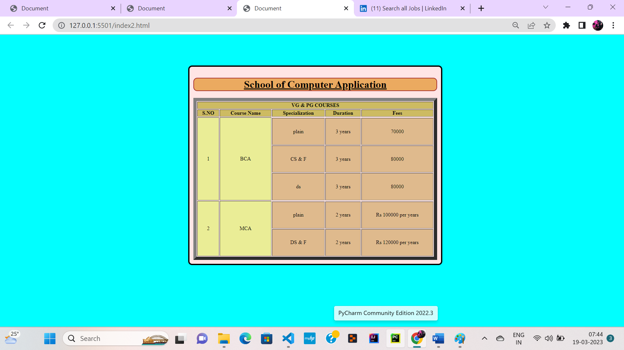

## Frameset in HTML:

### *index.html*

**<!DOCTYPE html>**

**<html lang="en">**

**<head>**

**<meta charset="UTF-8">**

**<meta http-equiv="X-UA-Compatible" content="IE=edge">**

**<meta name="viewport" content="width=device-width, initial-scale=1.0">**

**<title>frameset in Html 5</title>**

**</head>**

**<frameset rows="20%, 60% , *">**

**<frame name="f1"  src="page1.html">**

**<frameset cols="20%,60%,*">**

**<frame name="f2"  src="page2.html">**

**<frame name="f5"  src="page3.html">**

**<frame name="f3"  src="page4.html">**

**</frameset>**

**<frame name="f4"  src="page5.html">**

**</frameset>**

**</html>**

### *page1.html*

**<!DOCTYPE html>**

**<html lang="en">**

**<head>**

**<meta charset="UTF-8">**

**<meta http-equiv="X-UA-Compatible" content="IE=edge">**

**<meta name="viewport" content="width=device-width, initial-scale=1.0">**

**<title>page1</title>**

**</head>**

**<style>**

**body{**

**background-image: url("download.jpg");**

**background-color: rgb(36, 170, 59);**

**color: red;**

**height: 12121px;**

**}**

**.container{**

**display:inline-block;**

**position:absolute;**

**left: 64px;**

**top: 20px;**

**}**

**h1,h3{**

**position: sticky;**

**text-align: center;**

**}**

**h3{**

**color: rgb(244, 236, 235);**

**}**

**.cont{**

**position:fixed;**

**width: 100%;**

**background-image: url("download.jpg");**

**box-sizing: border-box;**

**}**

**</style>**

**<body>**

**<div class="cont">**

**<div class="container">**

**<img src="bbdlogo.png" alt="bbdlogo.png" width="80%" srcset="">**

**</div>**

**<marquee behavior="slide" direction="" scrollamount="20"><h1 ><u> Babu Banarsi Das University</u></h1><h3><u>Building the next generation</u></h3>  </marquee>**

**</div>**

**</body>**

**</html>**

### *page2.html*

**<!DOCTYPE html>**

**<html lang="en">**

**<head>**

**<meta charset="UTF-8">**

**<meta http-equiv="X-UA-Compatible" content="IE=edge">**

**<meta name="viewport" content="width=device-width, initial-scale=1.0">**

**<title>page2</title>**

**<style>**

**body{**

**background-color: rgb(123, 170, 150);**

**}**

**li{**

**padding: 8px;**

**}**

**li a{**

**text-decoration: none;**

**}**

**li a:hover,a.active{**

**text-decoration: underline;**

**color: blue;**

**}**

**/* li a:active{**

**text-decoration: underline;**

**color: rgb(28, 210, 101);**

**} */**

**</style>**

**</head>**

**<body>**

**<h3>LINKS</h3>**

**<ul>**

**<li>**

**<a href="About us.html" target="f5" >About US</a>**

**</li>**

**<li>**

**<a href="" target="" >Course offered</a>**

**</li>**

**<li>**

**<a href="" target="" >Faculties</a>**

**</li>**

**<li>**

**<a href="" target="" >Examination</a>**

**</li>**

**<li>**

**<a href="" target="" >Results</a>**

**</li>**

**<li>**

**<a href="" target="" >Feedback</a>**

**</li>**

**<li>**

**<a href="" target="" >Faculties</a>**

**</li>**

**<li>**

**<a href="" target="" >Examination</a>**

**</li>**

**<li>**

**<a href="" target="" >Results</a>**

**</li>**

**<li>**

**<a href="" target="" >Feedback</a>**

**</li>**

**</ul>**

**</body>**

**</html>**

### *page3.html*

**<!DOCTYPE html>**

**<html lang="en">**

**<head>**

**<meta charset="UTF-8">**

**<meta http-equiv="X-UA-Compatible" content="IE=edge">**

**<meta name="viewport" content="width=device-width, initial-scale=1.0">**

**<title>page3</title>**

**</head>**

**<body>**

**<img src="download (1).jpg" alt="" srcset="" width="800px">**

**</body>**

**</html>**

### *page4.html*

**<!DOCTYPE html>**

**<html lang="en">**

**<head>**

**<meta charset="UTF-8">**

**<meta http-equiv="X-UA-Compatible" content="IE=edge">**

**<meta name="viewport" content="width=device-width, initial-scale=1.0">**

**<title>page4</title>**

**<style>**

**body{**

**background-color: rgb(123, 170, 150);**

**}**

**li{**

**padding: 8px;**

**}**

**li{**

**text-decoration: none;**

**}**

**a:hover{**

**text-decoration: underline;**

**color: blue;**

**}**

**a.active{**

**text-decoration: underline;**

**color: blue;**

**}**

**ol li a{**

**color: rgb(234, 4, 4);**

**}**

**ol li{**

**color: rgb(234, 4, 4);**

**}**

**</style>**

**</head>**

**<body>**

**<h3>COURSES</h3>**

**<ul type="square">**

**<li >**

**<details>**

**<summary> <a href="" target="f5" >MCA</a></summary>**

**<ol type="i">**

**<li><a href="">Normal Mca</a> </li>**

**<li><a href="">Mca by IBM</a> </li>**

**</ol>**

**</details>**

**</li>**

**<li >**

**<details>**

**<summary> <a href="" target="f5" >BCA</a></summary>**

**<ol type="i">**

**<li><a href="">Normal Bca</a> </li>**

**<li><a href="">Bca by IBM</a> </li>**

**</ol>**

**</details>**

**</li>**

**</ul>**

**</body>**

**</html>**

### *page5.html*

**<!DOCTYPE html>**

**<html lang="en">**

**<head>**

**<meta charset="UTF-8">**

**<meta http-equiv="X-UA-Compatible" content="IE=edge">**

**<meta name="viewport" content="width=device-width, initial-scale=1.0">**

**<title>Page5</title>**

**<style>**

**body{**

**text-align: center;**

**}**

**p{**

**width: 40%;**

**margin: auto;**

**}**

**</style>**

**</head>**

**<body bgcolor="green" text="red" >**

**<h3>Contact Us</h3>**

**<p>Babu Banarsi Das University</p>**

**<h6>Phone number:9432344532,78990334253</h6>**

**<p>Lorem ipsum dolor sit amet consectetur adipisicing elit. Iste laborum officiis quos. Nemo unde mollitia illum blanditiis voluptatem consequuntur quas laudantium veniam et ex! Aliquid, doloremque. Consequatur amet vitae, mollitia ex veritatis voluptates quae?</p>**

**</body>**

**</html>**

# OUTPUT:

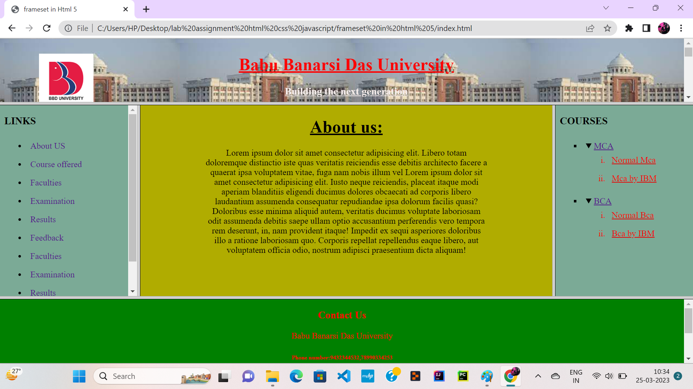

## Implementation of External CSS in Web Pages:

### *index.html*

**<!DOCTYPE html>**

**<html lang="en">**

**<head>**

**<meta charset="UTF-8">**

**<meta http-equiv="X-UA-Compatible" content="IE=edge">**

**<meta name="viewport" content="width=device-width, initial-scale=1.0">**

**<link rel="stylesheet" href="mystyle.css">**

**<title>external css</title>**

**</head>**

**<body>**

**<div class="container">**

**<h2>Working with inline CSS</h2>**

**<hr>**

**<table border="10">**

**<thead>**

**<tr>**

**<th> <span> S.NO</span></th>**

**<th><span>STUDENT NAME</span></th>**

**</tr>**

**</thead>**

**<tbody>**

**<tr>**

**<td>1001</td>**

**<td>XYZ</td>**

**</tr>**

**<tr>**

**<td>1002</td>**

**<td>PQR</td>**

**</tr>**

**<tr>**

**<td>1003</td>**

**<td>MNO</td>**

**</tr>**

**<tr>**

**<td>1004</td>**

**<td>SUP</td>**

**</tr>**

**<tr>**

**<td>1005</td>**

**<td>DYZ</td>**

**</tr>**

**</tbody>**

**</div>**

**</table>**

**<hr>**

**<h1 class="heading">Babu Banarsi Das University</h1>**

**<hr>**

**<h1 class="heading"><em>Department of MCA</em> </h1>**

**<hr>**

**</div>**

**</body>**

**</html>**

### *mystyle.css*

**body{**

**background-color: rgb(100, 232, 181);**

**}**

**hr{**

**border:6px solid rgb(0, 0, 255);**

**}**

**h2{**

**color: rgb(235, 8, 201);**

**padding: 23px;**

**}**

**.heading{**

**padding: 23px;**

**color:brown;**

**}**

**.container{**

**text-align: center;**

**width: 750px;**

**padding: 12px ;**

**margin: 23px auto;**

**background-color:skyblue;**

**border: 4px solid;**

**border-radius: 12px;**

**}**

**span{**

**background-color: rgb(19, 218, 240);**

**}**

**table{**

**width: 750px;**

**height: 400px;**

**color:red;**

**background-color: brown**

**}**

**thead{**

**background-color: rgb(230, 201, 56);**

**}**

**tbody{**

**background-color: rgb(235, 241, 49);**

**}**

# OUTPUT:

